WI. How to place a ticket to SPP as a plant, carrier and supplier.

Choose:
- Packaging
- Packaging orders
- Other
- Special
- Country
- Subject

Submit your request. e.g. V-EMB 6016

, 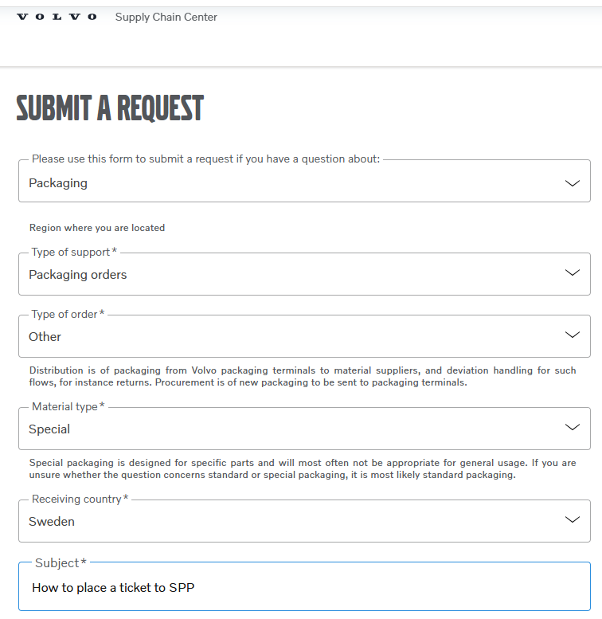

Enter your request. e.g. as below.
You can add before you submit:
- Add attachment
- Add CC
- Then submit.
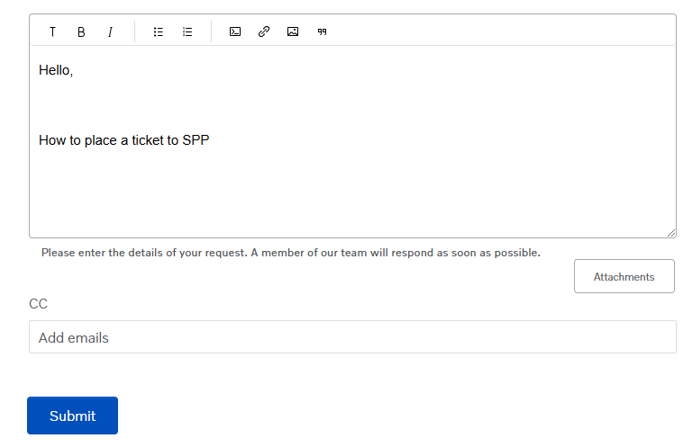

WI. How to place a ticket to SPP as a Terminal/Depots

Choose:
- Packaging
- Terminal operations
- Other
- Responsible department: Packaging operations
- Material type: Special
- Terminal number
- Subject
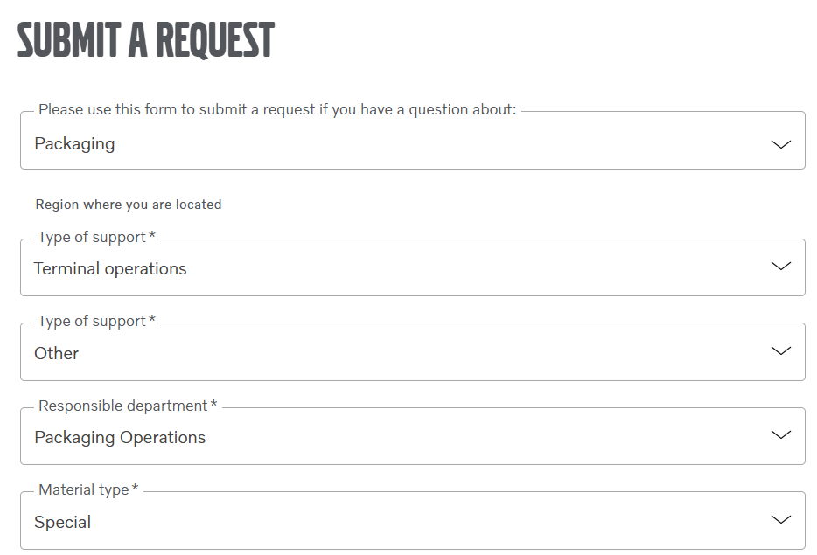
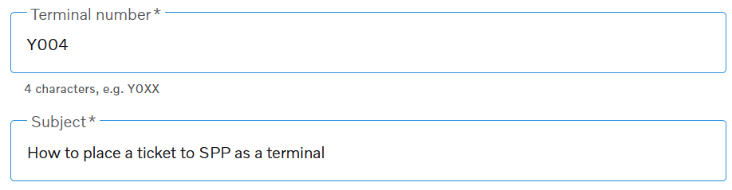

Submit your request.

Enter your request. e.g. as below.
You can add before you submit:
- Add attachment.
- Add CC.
