
L A B E L O R D E R F O R M

USER FOR EMPTY PACKAGING RETURNS,

FORM ATTACHED TO TICKET & SENT TO:
https://supplychain.volvo.com/ Route: Packaging / Return of empty packaging / Regular / label order
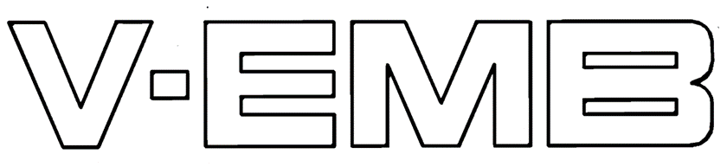
ORDERS SHOULD BE PLACED LATEST 2 WEEKS IN ADVANCE.
LABEL DETAILS | COMPANY NAME to go on LABEL  (Max 14 Digits) |  |  |  |  |  |  |  |  |  |  |  |  |  |  |  | SLOC no. |  |  |  | EMB NUMBER/S (IF REquiRED)  (TY 2116, 2118 only)
DELIVERY DETAILS Addition Information
Company name
Address
City
District / County
Zip/Post Code / Country
Contact Name / E-mail
Phone
Total Quantity Required | TYPE | REF CODE | DESCRIPTION | PICTURE
 | Plain  Free issue No Charge | TY2114 | ‘Packed and Controlled by’ (A7)  Used on all bundles where content is visible  Storage Location number, Company name & signature box
 | Self-Adhesive  Charge applied | TY2116 | ‘Packed and Controlled by’ (A5)  Used on all bundles where content is not visible  Company name, storage location number & signature box additional fields for EMB number, quantity & date
 | Plain  Free issue No Charge | TY2118
 | Plain  Free issue No Charge | TY2120 | ‘Clean Packaging’ (A6)  Used on all some types of bundles where content does not require washing  Company name, storage location number
 | Plain  Free issue No Charge | TY2147 | ‘Packaging must be repaired’ (A6)  Used on bundles or pieces of damaged packaging, to be attached by staple  Company name, storage location number
 | Self-Adhesive  Free issue No Charge | TY2152 | ‘Packaging must be repaired’ (Luggage tag)  Used on bundles or pieces of damaged packaging  Company name, storage location number
 | Plain  Free issue No Charge | TY2148 | ‘Packaging must be repaired’ (A5)  Can be used on damaged steel racks in combination with TY2152 to specify what’s damaged | 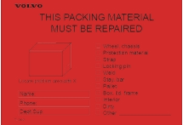
 | Plain  Free issue No Charge | TY2150 | ‘Packaging not for use’ (A6)  Used for quality follow up and scrap packaging Sending and receiving company name, SLOC number

Please check to ensure that the details are correct.
Thank you for your ORDER

