How to use Packaging Data for Nii case Issuers Qlik app
Table of Contents
How to use Packaging Data for Nii case Issuers Qlik app 1
How to gain access to the app and where to find it 2
Access 2
Where to find the app 4
How to find correct SLOC number 5
How to find which types of packaging the supplier has and if they use them. 5
Sheets contained in the app 5
Packaging Customer List 5
Packaging Contact Person Information 6
Packaging User Information 6
Packaging Restriction Table 7
Material assigned to Slocs 8
Sloc and Registration details 8
PackIT vs LES Data Check 9
OC/FC Parma match with SLOC 10
Relation Comparison (TND vs LES) 11
Turnover 12
PackIT Users Information 12
Low Volume Calculator 13

How to gain access to the app and where to find it

Access
Go to Data Platforms in MySupport.
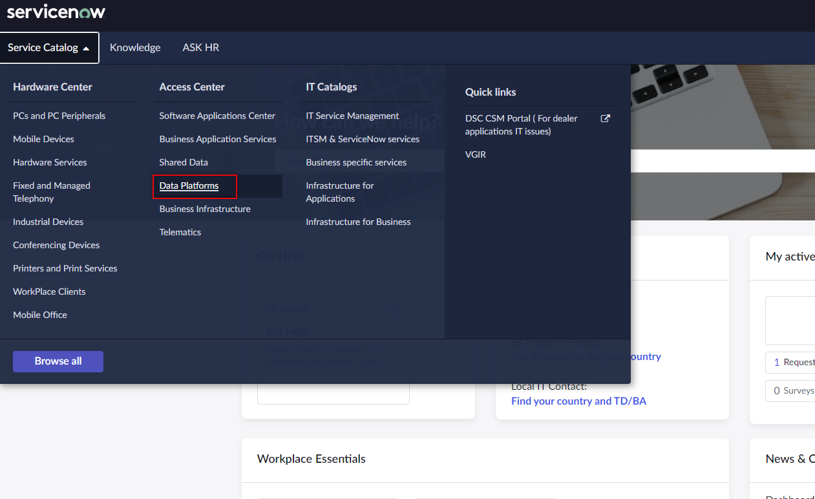

Choose Qlik Access Request
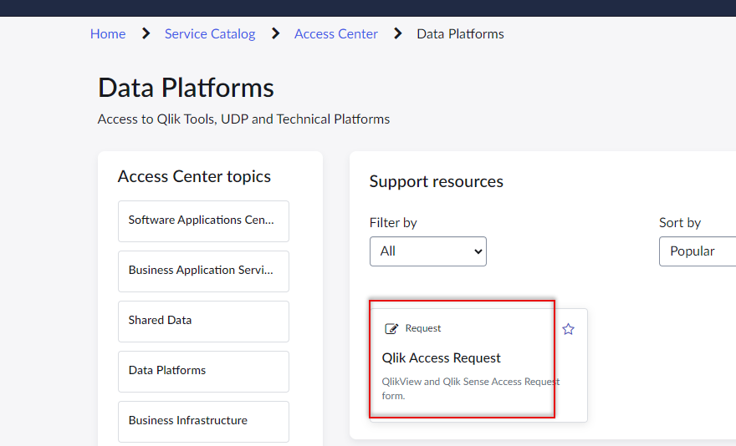
Choose:
- QlikSense
- Grant
- Stream
- GTO-ManagePackaging
- EndUser
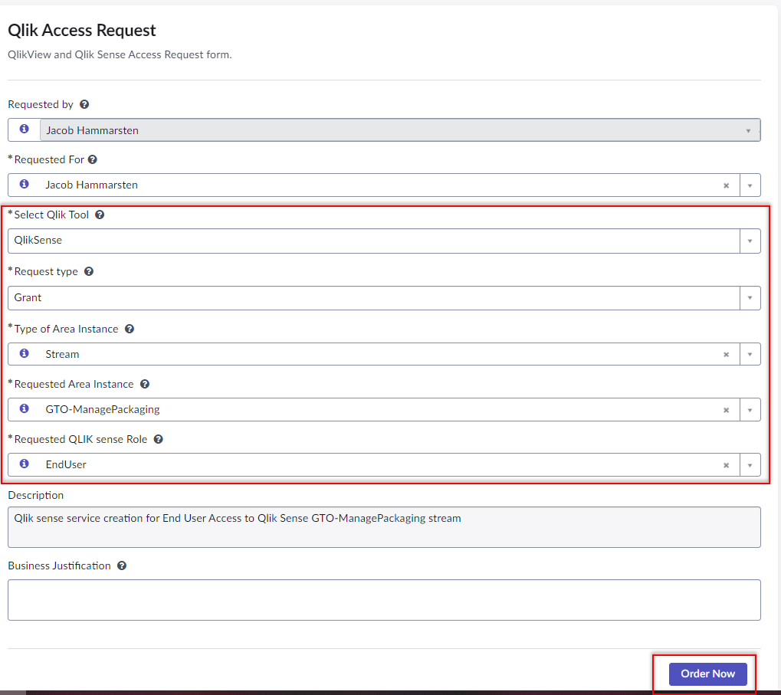

Note that you can request access for others and that it is the manager of the requested user that needs to approve the request.
You can check the approver by going in to the submitted request and then following the pictures below.
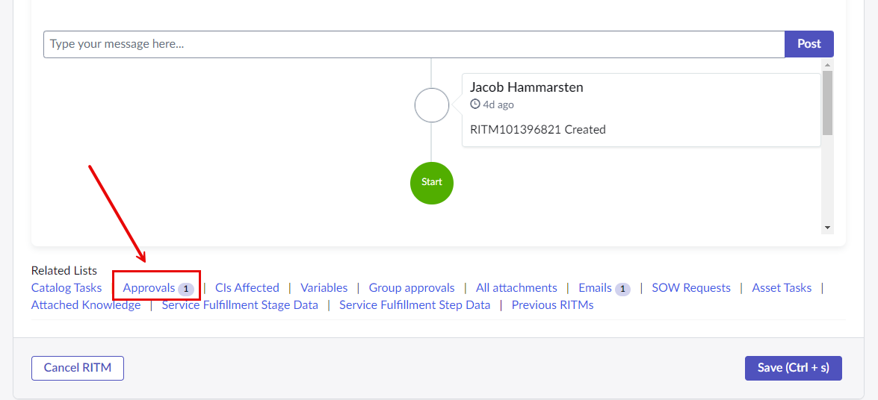
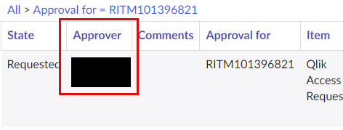

Where to find the app
Go to the QLIK Hub: https://qliksense.udp.volvogroup.net/hub/
Navigate to the GTO-ManagePackaging stream and find the Packaging Data for Nii case Issuers app.
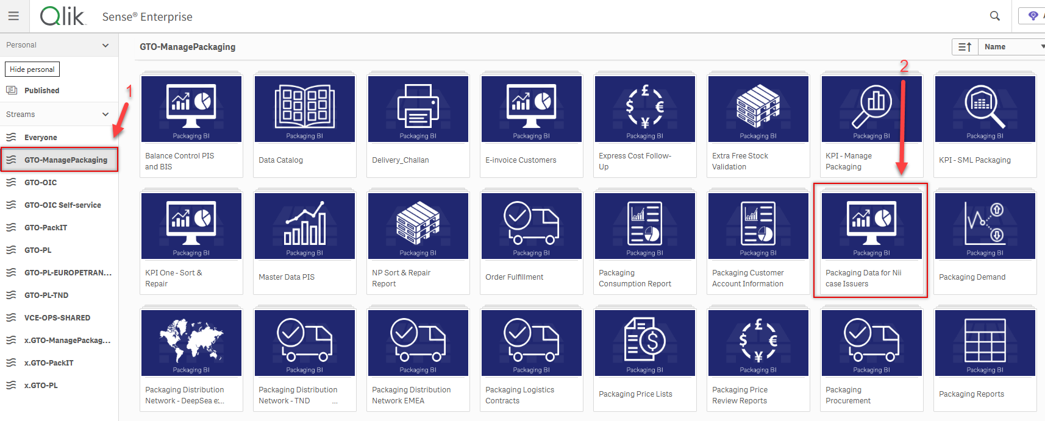

How to find correct SLOC number
Storage Location (SLOC) is the account number of a packaging user. All users of our PL owned Volvo packaging should have a SLOC account.
If you know the FC Parma number (Ship-From parma):
- Go to OC/FC Parma match with SLOC and filter on FC. If you cannot find a matching SLOC then go to the next step.

If you do not know the FC Parma number or could not find a match in the previous step:
- Go to Packaging Customer List and search for a SLOC using address information, names or invoicing parma of the packaging user.

If you still cannot find a SLOC then it is likely that no SLOC has been created for the user on the address that you are looking for. In this case, please create a Nii case to create a new SLOC.

How to find which types of packaging the supplier has and if they use them.
In the Material assigned to Slocs sheet you can find the types of packaging available for the SLOC to order in the LES portal. Filter on SLOC.
If a material is marked as “Material.Deleted” – “YES”, then the SLOC has had the packaging type at one point, but it has since been removed from the account.
If you know that a SLOC is or is supposed to be using a packaging type that they do not have available, then please create a Nii case for the packaging type and inform the user about it.

Sheets contained in the app

Packaging Customer List
This sheet contains extensive information about each SLOC account and how they are set up in SAP.
The sheet is useful when trying to find the correct SLOC or if you are curious about how an account is set up in general.
Useful filters and columns include:
- Sloc: Storage location number, useful to filter on.
- Customer Name: Useful when trying to find correct SLOC number.
- Packaging Parma: Useful when trying to find correct SLOC number. Note that this is the invoice parma and it is not the same as OC or FC parma.
- FC Parma: Use when trying to find correct SLOC number. Manually added by MP.
- Status: Useful to filter on to only view Active accounts.
- Main & Sub Category: Shows what type of packaging user the account is categorized as. This can have an impact on how they are treated and what type of agreements they have for example.
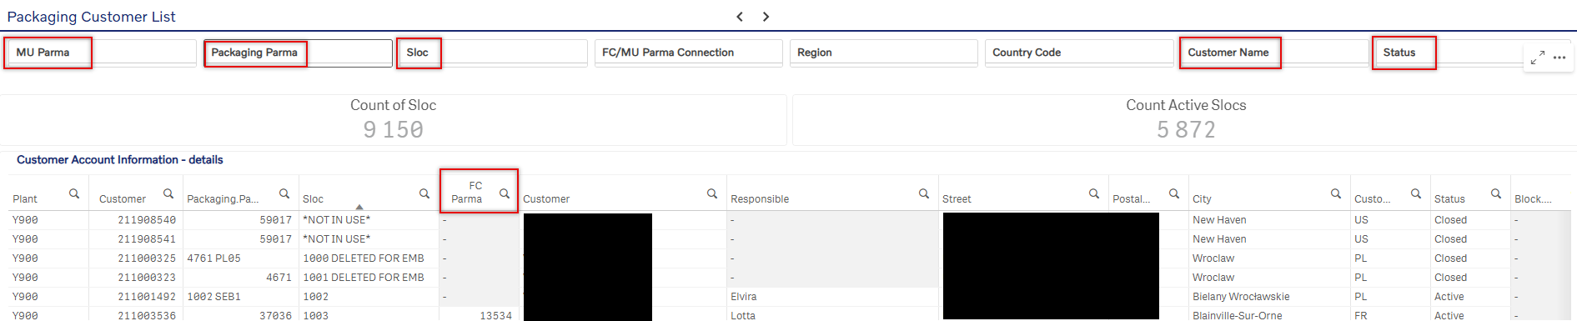
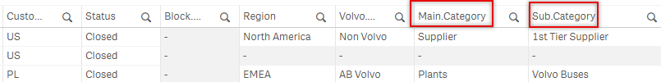

Packaging Contact Person Information
This sheet contains all contact information that we have connected to the SLOCs.
The sheet can be useful when trying to find a contact for the Nii case or if you want to get in contact with a packaging user for packaging related topics.
Useful filters and columns include:
- Sloc: Storage location number, useful to filter on to find the correct contact.
- Contact type: Filter on “Packaging Contact” when viewing the contacts for most relevant contact info.
- Email Address: Contains the email address of the contact.
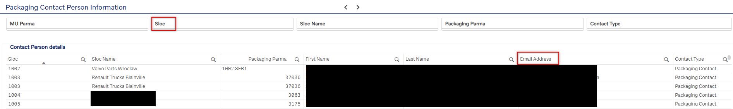

Packaging User Information
This sheet contains information about the user ID’s that have or has had access to a SLOC and to the LES portal.
The sheet can be useful when trying to find a contact for the Nii case or if you want to know which users have or have had access to a SLOC account.
Useful filters and columns include:
- Sloc: Storage location number, useful to filter on.
- User ID: Useful to filter on.
- Validity Check: Useful to filter on if you only want to see users with Valid/active access.
- User Type: Useful if you want to quickly see who is a Volvo employee and who is not.
- User Email Address: Contains the email address of the user ID.
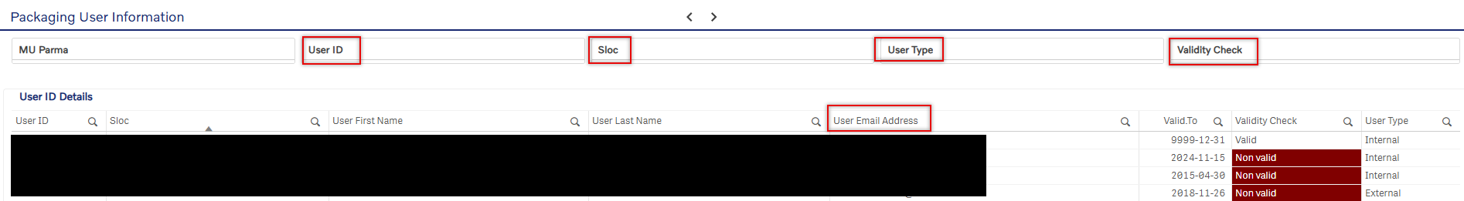

Packaging Restriction Table
This sheet contains information about the active flows of packaging in SAP. The restriction table shows the receivers that a SLOC can send packaging towards in the LES portal and which SLOC’s can send packaging towards them.
The sheet can be useful when finding out if a Nii case is needed. It can also be used to view which flows are available in for a packaging user in the LES portal.
Useful filters and columns include:
- Sender Sloc: Useful filter to see towards which SLOC’s a user can send packaging towards in the LES portal.
- Receiver Sloc: Useful filter to see from which SLOC’s a user can receive packaging from in the LES portal. Note that request flows (REQU) are not included in this table. REQU are flows from our packaging terminals towards packaging users that order empty packaging.
- Transaction Type: Useful information to see what type of flow the table shows. There are 2 types:
  - MOVE: This type of flow does not produce any usage fee and should normally represent a flow of empty packaging towards a non-terminal SLOC or a flow of filled packaging (parts packed in V-EMB) towards a PUP categorized SLOC.
  - USAG: This type of flow will generate a usage fee and is the most common type of flow and should represent the flow of filled packaging (parts packed in V-EMB).

- Customer Flow: Useful to determine who the payer of the usage fee is. If the customer group =
  - AB Volvo then the usage fee will be issued towards the receiving SLOC as a standard if no payment agreement has been set-up.
  - Joint Ventures then the usage fee will be issued towards receiving SLOC as a standard if no payment agreement has been set-up.
  - Medium External then the usage fee will be issued towards the sending SLOC as a standard if no payment agreement has been set-up.
  - Pick Up Points(PuP) then there will be no usage fee generated. Instead there will be be a higher usage fee issued for the next leg towards the receiving SLOC.

- Payer & Payer Name: Useful to see if a payment agreement has been set up and who is the payer for the USAG flows.
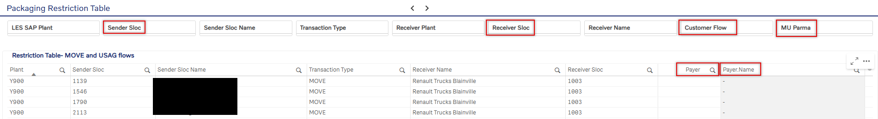

Material assigned to Slocs
This sheet contains information about which V-EMB types a SLOC has or does not have available on their account for ordering or booking purposes.
The sheet can be useful if you want to check what types of packaging a SLOC has or does not have available to order. Note that just because a supplier has a packaging type available does not mean that they are using it physically. For more information about that, see section: How to find which types of packaging the supplier has and if they use them.
Useful filters and columns include:
- Sloc: Storage location number, useful to filter on.
- Old Material: This is the short version of our packaging numbers, just the last digits. For example, the old material: 21 = 9900000021. Useful as a filter.
- Material Deleted: If a packaging type has been available to a SLOC at one point but has since been deleted, then the “Material.Deleted” = “YES”.
- Material.Group1: Shows who the owner of the packaging type is.
- Material.Group3: Shows who the responsible manager of the packaging type is.
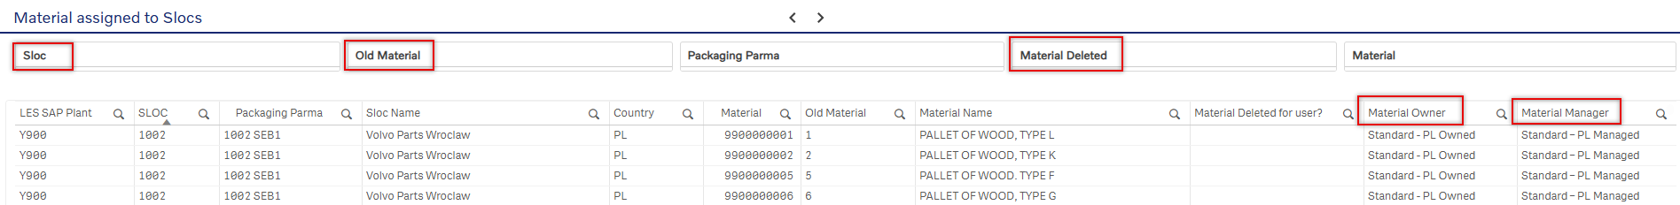

Sloc and Registration details
This sheet contains information about the bookings of V-EMB from one account to another.
This can be useful when trying to figure out how much packaging a user is using. You will find data for each V-EMB type.

Useful filter and columns include:
- Sloc: Storage location number, useful to filter on.
- Sender Sloc: Useful filter to see towards which receives a user is sending packaging including the types & quantities.
- Receiver Sloc: Useful filter to see from which SLOC’s a user has received packaging from including the types & quantities.
- Booking Date: Useful column to see which date a booking was created on. Can be sorted on to see the latest or oldest bookings.
- Material: Key information about which type of packaging is being used/booked. Also useful as filter.
- Quantity: Here you can see the amount of packaging booked by the user in pieces of packaging.
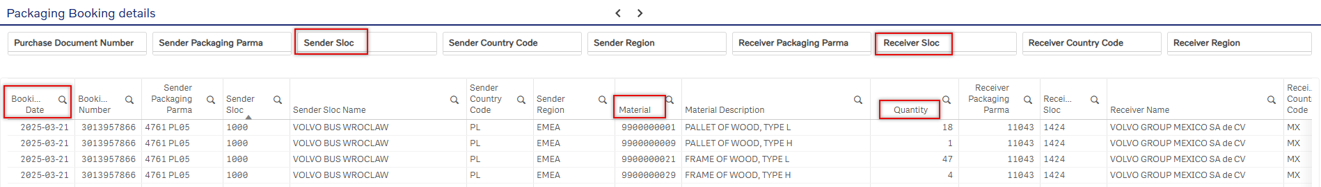

PackIT vs LES Data Check
This sheet contains information about differences between PackIT & LES data. You will find two tables in the sheet showing two types of errors/differences between the systems. The data that is compared to LES is transport booking data from ShipIT and the packaging instructions used in those bookings.
If an instruction appears either of the tables, there is one of two actions needed.
- Either check with the supplier and see what they physically use and adjust the instruction.
- Or create a nii case for the packaging type not available for the SLOC and if the case is approved, contact the supplier to secure their packaging compliance.
Important to know is that the instructions are placed on the OC parma level, but an OC can have many FC parmas (ship from locations) connected to it and therefor several SLOC’s.
Useful filter and columns include:
- Sender Sloc: Storage location number, shows the packaging account related to the information. Also useful to filter on.
- FC Parma: Use if you do not know the SLOC number. Manually added by MP.
- Material user: Shows the number of the receiving material user. Very useful to filter on.
- TBR: Shows the transport booking request of the ShipIT booking. Useful to filter on to see which specific transport used the instruction, part number and packaging type.
- Pack Instruction: Shows the packaging instruction used in the transport booking. Also useful to filter on.
- Part Number: Shows the part number used in the transport booking. Also useful to filter on.
- Material: Key information about which type of packaging is being used/booked but that is not available for the SLOC in LES system.
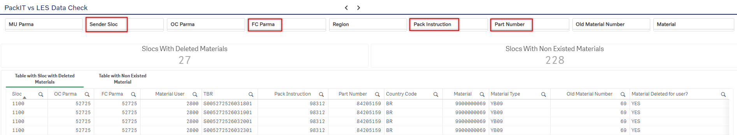

Table with Sloc with Deleted Material
This table contains information about which material types are deleted from a SLOC’s account but still included in its packaging instruction in PackIT.
This means that the SLOC has been able to order the type at some type before but cannot order it any longer. However, the packaging type was still contained in the instruction in PackIT at the time of the transport booking.

Table with Non Existed Material
This table contains information about which material types have never existed a SLOC’s account but is still included in its packaging instruction in PackIT.
This means that the SLOC has never been able to order the V-EMB type in the table. However, the packaging type was still contained in the instruction in PackIT at the time of the transport booking.
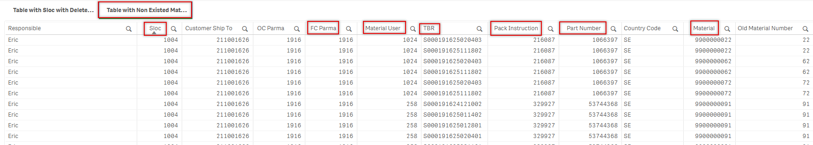

OC/FC Parma match with SLOC
This sheet contains information about manual matches that have been made between SLOC numbers & FC Parma numbers. This match allows issuers to find the correct SLOC number if they only have FC Parma or ship from address information.
To find the correct SLOC with high certainty and you have the:
- FC Parma
  - Simply enter the FC parma number in the filter marked in the picture below and see if a SLOC number exists in the SLOC column of the table.
- Ship From address
  - Filter on the “FC Parma Street” and see if a SLOC number exists in the SLOC column of the table. Note that the street information is not always 100% the same in all system so you can also filter on the “FC Parma Postal” and “FC Parma City” if necessary to locate the correct street & SLOC.

It is also possible to find SLOC’s using other data such as the OC Parma/Supplier Parma or Name but note that this might lead to results with low certainty since a SLOC represents one physical location using V-EMB while an OC Parma & Names can represent many different manufacturing sites -such as the HQ office of a company for example.
Useful filter and columns include:
- Sloc: Storage location number, shows the packaging account related to the information.
- FC Parma: Use if you do not know the SLOC number. Manually connected by Manage Packaging.
- FC Parma Street: Shows the ship-from street. Useful when trying to locate the matching SLOC.
- FC Parma City: Shows the ship-from city. Useful when trying to locate the matching SLOC.
- FC Parma Postal: Shows the ship-from postal code. Useful when trying to locate the matching SLOC.
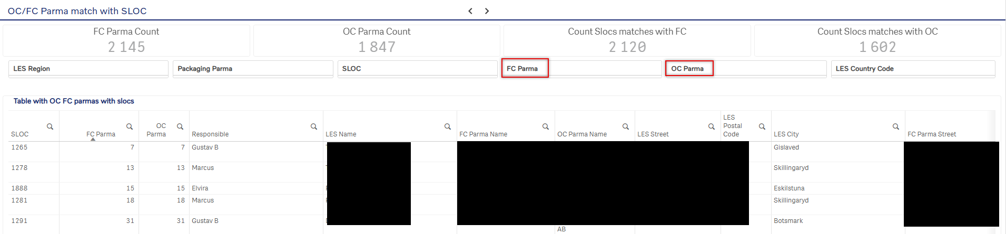

Relation Comparison (TND vs LES)
This sheet contains a comparison between TND & LES data. You will find a table containing SLOC relations, sending & receiving SLOC. The sheet is different from the Packaging Restriction Table because it contains relations that do not exist in the LES system but instead in the TND system. This means that the sending SLOC can create a booking towards a receiver in ShipIT but they cannot book any packaging in LES. It also includes data such as MU, FC & gates of the sending/receiving SLOC.
The data can be useful if an issuer wants to secure that all Nii cases have been created towards their MU. The easiest way to check this is by filtering on the receiving MU or SLOC and then selecting filtering “LES Flow Existed” on “NO”. This will generate data of SLOC’s that can create transport bookings but not LES packaging bookings towards you.
Useful filter and columns include:
- FC Parma: Use if you do not know the SLOC number. Manually connected by Manage Packaging.
- Sloc: Sending storage location number, shows the sending packaging account of that relation.
- MU SLOC: Receiving storage location number, shows the receiving packaging account of that relation
- LES Flow Existed: Useful to filter on to see relations that exist or does not exist in LES system. Also visible in the table.
- Material User Parma: Receiving plant number.
- Gate: Useful to filter on if issuer wants to check specific relation.
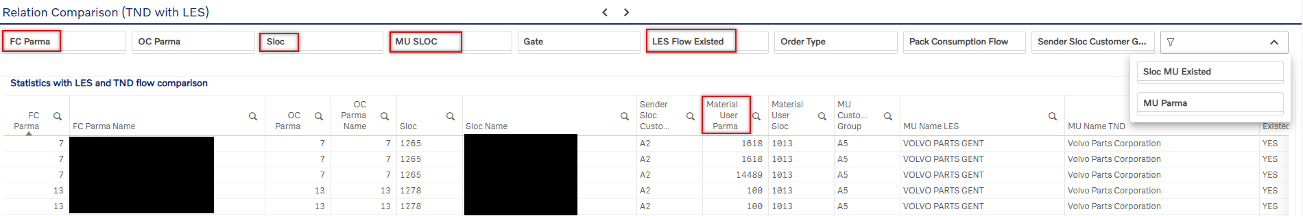

Turnover
This sheet contains a graph and a table to visualize the turnover of packaging at a SLOC. The higher the turnover, the faster the supplier uses our packaging during a specific period.
It can be useful information to see how much and how fast a supplier uses packaging.
Useful filter and columns include:
- Sloc: Storage location number, useful to filter on.
- Turnover Status: Useful information to see if a supplier is a labeled as a “low volume” supplier or not.
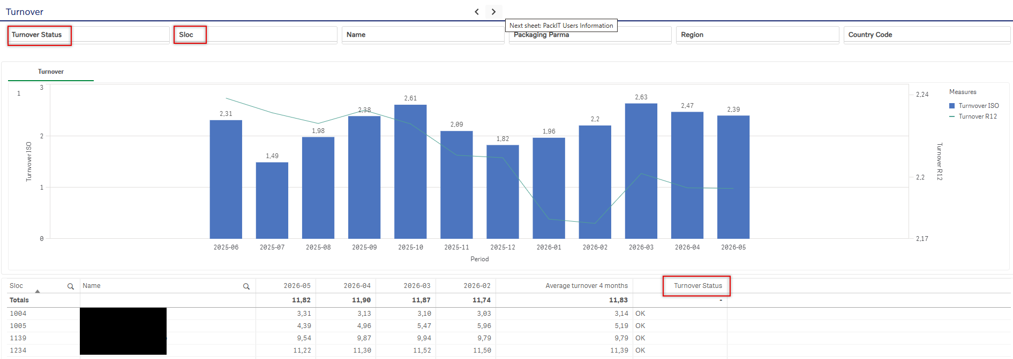

PackIT Users Information
This sheet contains user information about PackIT user ID’s. Can be useful when wanting to find a contact for Nii cases.
Useful filter and columns include:
- PackIT.User: Useful to filter on the user ID when wanting to find which OC it is related to or to find the email.
- OC Parma: Useful to filter on to find the PackIT users related to a specific OC.
- PackITUser.Email: Contains email information connected to the User ID.
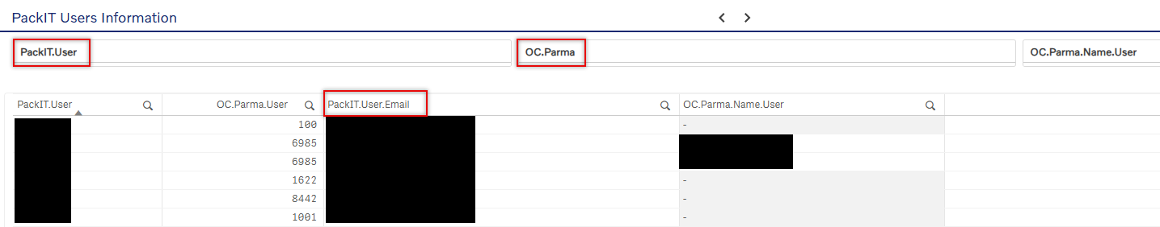

Low Volume Calculator
This sheet contains a calculator that is intended to help nii case issuers get an idea of how long it takes a user/supplier to use 1 bundle of a packaging type given a selected yearly quantity/demand of that packaging.
If the result shows in red, then it will likely take longer than 3 weeks for a supplier to use 1 bundle of packaging type and if it shows green then it will take less than 3 weeks.
For more information and guidance, click the question mark in the top right corner.
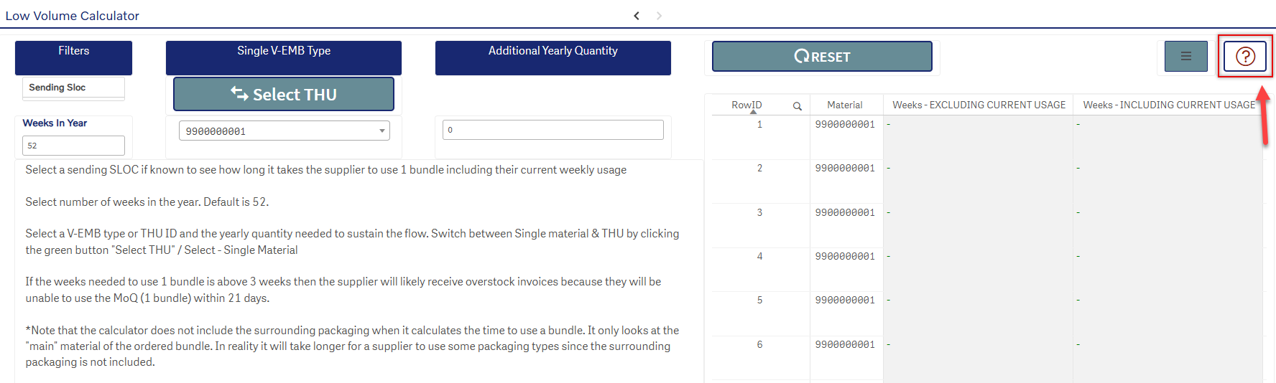
Also note that you will find a link to the packaging fee calculators such as the usage fee in the bottom right corner.
